Student Intervention

# 1. Classification vs Regression

This is a classification problem, as we are aiming to predict what is the likelihood of the student to fail so that we can intervene at correct time so as to help him out. Moreover, this is a binary classification problem with two classes fails / pass.

# 2. Exploring the Data

Can you find out the following facts about the dataset?

* Total number of students : ​**395**
* Number of students who passed : **265**​
* Number of students who failed : **130**​
* Graduation rate of the class (%) : ​**67.09**
* Number of features (excluding the label/target column) : **30**​

Use the code block provided in the template to compute these values.

# 3. Preparing the Data

Execute the following steps to prepare the data for modeling, training and testing:

* Identify feature and target columns
* Preprocess feature columns
* Split data into training and test sets

Starter code snippets for these steps have been provided in the template.

The code has been written and added in the ipython notebook

# 4. Training and Evaluating Models

Choose 3 supervised learning models that are available in scikit­learn, and appropriate for this problem. For each model:

## Naive Bayes

This is very quick to train and predicting because it is the simplest model which can be used in order to predict thing very fast as its complexity is O(cd + nd) where c is the number of classes and the n is the number of data points and d is the number of features. It is best used in text classification problems like spam email detection where we need predictions very fast, face recognition etc. But being very simplistic it assumes that all the features are conditionally independent given the target. Example of two conditionally independent variables could be the heights of two children born in the same year, their heights are correlated (as they are both growing up) but conditionally independent given their age (once we know the age of the first child the height of the second child does not provide us with any more information w.r.t the first child’s height). Though, the predictions produced by this model might not be very accurate but the class predictions produced can in fact be quite accurate. But it even it does not overfit the data. F1­ Score increases with increase in number of training data points.

### Advantage:

1. Simple and Fast
2. If the NB conditional independence assumption actually holds, a Naive Bayes classifier will converge quicker than discriminative models like logistic regression, so you need less training data.
3. In text classification like problems Naïve Bayes is a good approach to go with in examples like to mark an email as spam, or not spam ? Classification of news articles about some topics like sports, politics etc or in sentiment analysis where we want to classify the tweet or any other comment as positive or negative.

### Disadvantage:

1. It has strong feature independence assumptions
2. If you have no occurrences of a class label and a certain attribute value together then the frequency-based probability estimate will be zero. Given Naive-Bayes' conditional independence assumption, when all the probabilities are multiplied you will get zero and this will affect the posterior probability estimate.
3. If used in classification problem with a small data set, precision and recall will be very low.

|  |  |  |  |
| --- | --- | --- | --- |
| Training Data | 100 | 200 | 300 |
| Training Time (sec) | 0.001 | 0.001 | 0.001 |
| Prediction Time (Test)(sec) | 0.001 | 0.001 | 0.001 |
| F1 ­ Score (Training) | 0.494117647059 | 0.81060606060  6 | 0.785542168675 |
| F1 ­ Score (Testing) | 0.408602150538 | 0.75 | 0.791044776119 |

## Random Forest Classifier

With fairly small number of data points random forest can easily be used irrespective of its high time complexity. This is best suited for the problems where features are very likely to be dependent on each other or can be explained through trees thus using an ensemble of tree is a good approach. As it is evident from the following table that the training is very overfitted with less number of data points thus, as it assumes that all the features are mutually exclusive from each other which is not the case all the time, thus resulting in high F1­ Score with less training data where it is more likely to overfit the data because of mutually exclusive assumption. Random Forest is being used in lot of data minning and AI application like understanding of genes, customer analytics as we can the feature importance metrics. Random Forest in being used in Xbox Kinect also to predict the movements of body parts

### Advantage:

1. The Random Forests algorithm is a good algorithm to use for complex classification tasks. The main advantage of a Random Forests is that the model created can easily be interrupted, that is we can identify the features that drives the model most i.e the important features of our datasets. We can identify the important features by getting the feature importance metrics.
2. For complex classification problems random forest is a suitable choice as they do not expect linear features or even features that interact linearly and can also deal with high dimensional space.

### Disadvantage:

1. The main limitation of the Random Forests algorithm is that a large number of trees may make the algorithm slow for real-time prediction i.e. online predictions is really slow for real-time application.

|  |  |  |  |
| --- | --- | --- | --- |
| Training Data | 100 | 200 | 300 |
| Training Time (sec) | 0.045 | 0.022 | 0.037 |
| Prediction Time (Test) | 0.001 | 0.001 | 0.001 |
| F1 ­ Score (Training) | 1.0 | 0.992307692308 | 0.992405063291 |
| F1 ­ Score (Testing) | 0.629921259843 | 0.755905511811 | 0.832116788321 |

## Support Vector Machines

Though this is the most computationally expensive algorithm as it has cubic time complexity, but because of its good classification results where we separable problems can easily be classified with high accuracy such as bioinformatics classification and image classification. As it comes with a kernel trick which can be used to convert nonlinear problem to linearly separable problem and thus finding the optimal hyperplane between the classes, but it seems to over fit if too many features were given, as in our case we have just 30 features therefore it performed really well. With the increase in the number of records the F1­ Score for training and testing and training and testing time is increasing because the time complexity is a function of O(n^3) for training. If you train this model using Sequential Minimal Optimization (which is what libsvm and therefore scikit learn uses) their training time complexity is O(n³) in the worst case which means that they require 9 times as much computation to train on a data set only 3 times as large (not to mention that the algorithm must hold the entire training set in memory while this is done). Scikit learn main implementation of SVM's can thus only handle roughly up to 10,000 samples.

### Advantage:

1. High accuracy, nice theoretical guarantees regarding overfitting, and with an appropriate kernel they can work well even if you’re data isn’t linearly separable in the base feature space.
2. Especially popular in text classification problems where very high-dimensional spaces are the norm.
3. Have good generalization.
4. Though it is much slower but the kernel trick makes it very useful finding the non-linearity in the data like using RBF,Poly,etc kernel .

### Disadvantage:

1. Memory-intensive to train thus large time to train and tune the model, hard to interpret and understand how the model has been trained based on the features values.
2. Perhaps the biggest limitation of the support vector approach lies in choice of the kernel and selection of the kernel function parameters.

|  |  |  |  |
| --- | --- | --- | --- |
| Training Data | 100 | 200 | 300 |
| Training Time | 0.064 | 0.003 | 0.010 |
| Prediction Time (Test) | 0.001 | 0.001 | 0.002 |
| F1 ­ Score (Training) | 0.882352941176 | 0.881355932203 | 0.845986984816 |
| F1 ­ Score (Testing) | 0.774647887324 | 0.783783783784 | 0.833333333333 |

# 5. Choosing the Best Model

The best model of choice is Support Vector Machine. The other algorithms trailed performed poorly with increasing training set sizes compared to SVM.

1. The Gaussian Naive Bayes had a very fast and simple training and predicting time, but yielded a lower F1 score compared to SVM and even they do not have a good tuning potential.
2. The Random Forest Classifier had a much longer training time than SVM as a function of the number of trees and also has a lower F1 score.
3. SVM has a costly training time where the training time essentially doubles with each additional hundred datasets, it has a high performance that can handle large datasets well that are also unbalanced. SVMs can employ the use of kernels to fit the data in a higher dimensional space too using **kernel tricks**.

Given the ambitious goal of reaching a 95% graduation rate, this processing time is a small price to pay.

In our case as we can see there is not much difference in time complexity as we have just 30 features and 300 training data points thus, we can use SVC for the particular problem. As the F1­ Score training and testing quite impressive and quite evidently increasing too which is better than random forest (testing) though random forest has good training F1­ Score which indicates overfitting thus lead poor F1 ­ Score (testing), whereas even Naive Bayes even do not have such a good F1 ­ Score as compared to SVC. Therefore, SVC is the best choice.

**As SVC have 3 hyper parameters that can be tuned as well i.e. gamma, c, kernel but because of processing limitations of the machine (less memory and processor) where we are unable to tune SVM kernels cannot be tuned thus, only 2 Hyper parameters gamma and c has been used.**

**Grid CV Search and Stratified Shuffle Split has been used because the data is small and unbalanced.**

**What is the model’s final F1 score?** 0.810924369748

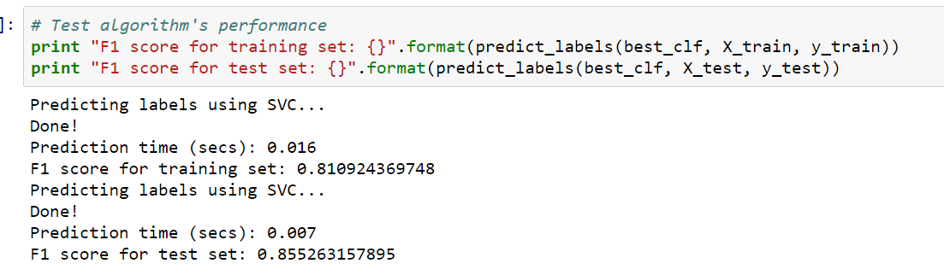

**How SVM Works ?**

For example, my task is to classify the student who may fail or pass the exam. I might say that many students who pass have parents who went to college, live near the school, don't have full-time jobs, do self-study for at least 3 hours a day, etc. A typical student who fails will have a full-time job, etc. The SVM algorithm will draw curves around these groups to separate them i.e. a boundary separating the two type of students to which either side will be different group of students.

Consider the following image where black dots represent the students who pass the exam and the white dots represents the students who fail the exam thus we can draw a boundary between these two groups of students which SVM find as there can be many such boundaries but SVM find the most optimum boundary that can efficiently divide the two groups. A decision line is one that separates between different sets of objects. In other words, given labelled training data as is in this supervised learning case, the algorithm outputs a clear divide that categorizes new examples. SVM chooses the best decision line or divide where the distance between that line and the nearest observations of differing classes are the largest. This can also be explained where, SVM try to fit a sheet of paper in between two classes fail and pass, while trying to place this sheet as a dead center between the two classes as possible which in the following diagram is the line in the center that has been found by SVM to separate the two cloud of points i.e. fail and pass in our case.

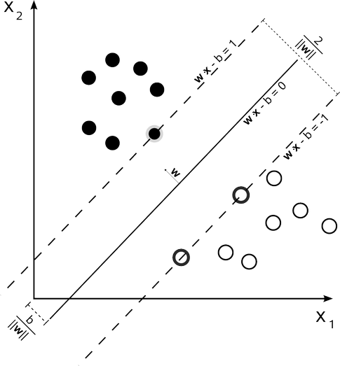

Figure 1. Finding the optimal margin using the support vectors

# References:

1. <http://blog.echen.me/2011/04/27/choosing-a-machine-learning-classifier/>
2. <http://www.svms.org/disadvantages.html>
3. <http://scikit-learn.org/stable/modules/svm.html>
4. <https://www.quora.com/What-does-support-vector-machine-SVM-mean-in-laymans-terms>
5. <http://stats.stackexchange.com/questions/22620/how-does-the-kinect-use-random-forests>
6. http://research.microsoft.com/pubs/145347/BodyPartRecognition.pdf